[--->Step 1: I navigate to page "Career Advice"[PASSED]<---]

[--->Step 2: I should see text "Home"[PASSED]<---]

[--->Step 3: I click on "Getting Started" career advice links[PASSED]<---]

[--->Step 4: I should be on page "Career Advice Getting Started"[PASSED]<---]

[--->Step 5: I navigate to page "Career Advice"[PASSED]<---]

[--->Step 6: I click on "Resume Tips" career advice links[PASSED]<---]

[--->Step 7: I should be on page "Career Advice Resume Tips"[PASSED]<---]

[--->Step 8: I navigate to page "Career Advice"[PASSED]<---]

[--->Step 9: I click on "Cover Letters" career advice links[PASSED]<---]

[--->Step 10: I should be on page "Career Advice Cover Letters"[PASSED]<---]

[--->Step 11: I navigate to page "Career Advice"[PASSED]<---]

[--->Step 12: I click on "Interviews" career advice links[PASSED]<---]

[--->Step 13: I should be on page "Career Advice Interviews"[PASSED]<---]

[--->Step 14: I navigate to page "Career Advice"[PASSED]<---]

[--->Step 15: I click on "At Work" career advice links[PASSED]<---]

[--->Step 16: I should be on page "Career Advice At Work"[PASSED]<---]

[--->Step 17: I navigate to page "Career Advice"[PASSED]<---]

[--->Step 18: I click on "Career Development" career advice links[PASSED]<---]

[--->Step 19: I should be on page "Career Advice Career Development"[PASSED]<---]

[--->Step 20: I navigate to page "Career Advice"[PASSED]<---]

[--->Step 21: I click on "Location Guides" career advice links[PASSED]<---]

[--->Step 22: I should be on page "Career Advice Location Guides"[PASSED]<---]

[--->Step 23: I navigate to page "Career Advice"[PASSED]<---]

[--->Step 24: I click on "Grads" career advice links[FAILED]<---]
  
[--->Failed Reason:
org.openqa.selenium.TimeoutException: timeout: Timed out receiving message from renderer: 30.000
(Session info: chrome=100.0.4896.127)
Build info: version: '4.6.0', revision: '79f1c02ae20'
System info: os.name: 'Mac OS X', os.arch: 'aarch64', os.version: '13.0.1', java.version: '19'
Driver info: org.openqa.selenium.remote.RemoteWebDriver$ByteBuddy$hYyLl87K
Command: [80e56ee06685baeb3f6972f54f43370c, clickElement {id=02b39a71-3081-4b53-8be3-d21f6581459e}]
Capabilities {acceptInsecureCerts: false, browserName: chrome, browserVersion: 100.0.4896.127, chrome: {chromedriverVersion: 100.0.4896.60 (6a5d10861ce8..., userDataDir: C:\Users\ltuser\AppData\Loc...}, goog:chromeOptions: {debuggerAddress: localhost:51263}, goog:loggingPrefs: {browser: ALL}, networkConnectionEnabled: false, pageLoadStrategy: normal, performance: false, platformName: WINDOWS, proxy: Proxy(), se:cdpVersion: 100.0.4896.127, setWindowRect: true, strictFileInteractability: false, timeouts: {implicit: 0, pageLoad: 300000, script: 30000}, unhandledPromptBehavior: dismiss and notify, video: true, webauthn:extension:credBlob: true, webauthn:extension:largeBlob: true, webauthn:virtualAuthenticators: true}
Element: [[RemoteWebDriver$ByteBuddy$hYyLl87K: chrome on WINDOWS (80e56ee06685baeb3f6972f54f43370c)] -> xpath: //ul[@id='menu-grey-nav']/li/a]
Session ID: 80e56ee06685baeb3f6972f54f43370c
at java.base/jdk.internal.reflect.DirectConstructorHandleAccessor.newInstance(DirectConstructorHandleAccessor.java:67)
at java.base/java.lang.reflect.Constructor.newInstanceWithCaller(Constructor.java:500)
at java.base/java.lang.reflect.Constructor.newInstance(Constructor.java:484)
at org.openqa.selenium.remote.codec.w3c.W3CHttpResponseCodec.createException(W3CHttpResponseCodec.java:200)
at org.openqa.selenium.remote.codec.w3c.W3CHttpResponseCodec.decode(W3CHttpResponseCodec.java:133)
at org.openqa.selenium.remote.codec.w3c.W3CHttpResponseCodec.decode(W3CHttpResponseCodec.java:53)
at java.base/java.util.function.Function.lambda$andThen$1(Function.java:88)
at org.openqa.selenium.remote.RemoteWebDriverBuilder.lambda$createExecutor$12(RemoteWebDriverBuilder.java:450)
at org.openqa.selenium.remote.RemoteWebDriverBuilder.lambda$createExecutor$13(RemoteWebDriverBuilder.java:456)
at org.openqa.selenium.remote.RemoteWebDriverBuilder.lambda$createExecutor$14(RemoteWebDriverBuilder.java:460)
at org.openqa.selenium.remote.RemoteWebDriverBuilder.lambda$createExecutor$15(RemoteWebDriverBuilder.java:469)
at org.openqa.selenium.remote.RemoteWebDriver.execute(RemoteWebDriver.java:541)
at org.openqa.selenium.remote.RemoteWebElement.execute(RemoteWebElement.java:257)
at org.openqa.selenium.remote.RemoteWebElement.click(RemoteWebElement.java:78)
at com.resumelibrary.utilities.Utility.clickOnElement(Utility.java:253)
at com.resumelibrary.webtest.candidate.CareerAdvicePage.clickOnCareerAdviceNavLinks(CareerAdvicePage.java:96)
at com.resumelibrary.cucumber.stepdefinitions.web.candidate.CareerAdvice.iClickOnCareerAdviceLinks(CareerAdvice.java:44)
at ✽.I click on "Grads" career advice links(file:///Users/shubhamr/Desktop/rl-selenium-web/./src/test/java/resources/featurefiles/web/candidate/careeradvice/CareerAdviceLoggedOut.feature:96)
<---]  
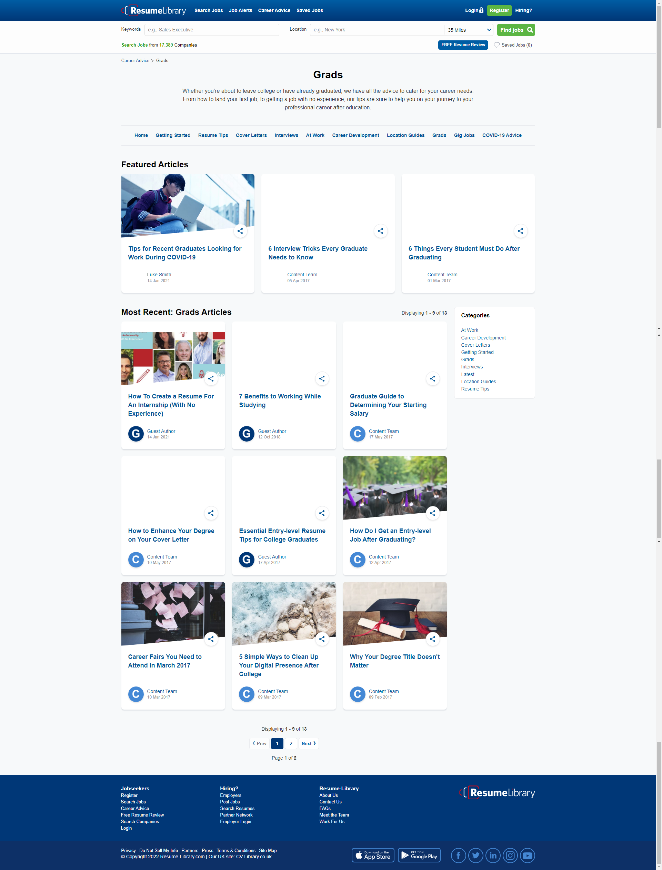

[--->Step 25: I should be on page "Career Advice Grads"[SKIPPED]<---]

[--->Step 26: I navigate to page "Career Advice"[SKIPPED]<---]

[--->Step 27: I click on "Gig Jobs" career advice links[SKIPPED]<---]

[--->Step 28: I should be on page "Career Advice Gig Jobs"[SKIPPED]<---]

[--->Step 29: I navigate to page "Career Advice"[SKIPPED]<---]

[--->Step 30: I click on "COVID-19 Advice" career advice links[SKIPPED]<---]

[--->Step 31: I should be on page "Career Advice Covid 19 Advice"[SKIPPED]<---]